# SIDDAGANGA INSTITUTE OF TECHNOLOGY (TUMAKURU)

An autonomous institution affiliate to Visveswaraya technological University , Belagavi Approved by AICTE , New Delhi , Accredited by NAAC and ISO 9001-2015 certified)

Social Connect and Responsibilities

Social Awareness Program Report



## Submitted by

**NAME USN**

# Dhanush Gowda A S 1SI23CI012

# Dhruva D 1SI23CI013

# Hemanth Kumar N K 1SI23CI015

# To

Dr H D Kallinatha Assistant professor Department of CSE, SIT

# Department of Computer Science & Engineering (ARTIFICIAL INTELLIGENCE AND MACHINE LEARNING)

(Program Accredited by NBA)

Siddaganga Institute of Technology

Social Connect and Responsibilities-SHS01

Final activity Evaluation 15 marks

## NAME: ABHISHEK HIREMATH USN: 1SI23CI003

After completion of the Social Connect and Responsibility,

* Students should prepare report of all modules individually and to be submit in file
* For final evaluation of Social Connect, students in group select presentation of any one module by discussing with coordinator and present like
  + Big poster presentation
  + Street play
  + One awareness program in college/school/university/government office/grama panchayat office/nearby villages/etc
  + Should submit evidence if the program done outside the campus.

|  |  |  |  |
| --- | --- | --- | --- |
| **Sl No** | **Evaluation Rubrics** | **Max.**  **Marks** | **Marks**  **Awarded** |
| **1** | Attitude and Commitment | **5** |  |
| Ability to Communicate with the Society | **5** |  |
| Acceptance of Responsibility and Contribution to  the Society | **5** |  |
| **TOTAL** | | **15** |  |

*(Poor-1, Fair-2, Acceptable-3, Excellent -4, Outstanding-5)*

Marks obtained = / 1 Signature of the Coordinator/ HOD

**Report on Manikarnika Walkathon: Awareness for Cleanliness of Tumkur City**

**Objective:** The Manikarnika Walkathon was organized to raise awareness about the importance of cleanliness in Tumkur city. The event aimed to engage the community and encourage collective responsibility for maintaining hygiene and sanitation across the city.

# Event Overview:

* **Date and Venue:** November, starting from Tumkur Bus Stand and concluding at the Municipal Office of Tumkur.
* **Organized By:** Sigma CSE Club, under the guidance of the Head of the Department (HoD) of Computer Science and Engineering (CSE).
* **Purpose:** To highlight the importance of cleanliness, advocate for better waste management practices, and submit a formal request to the Health Officer to prioritize sanitation measures.

# Activities:

1. **Walkathon Route:** The walkathon began at Tumkur Bus Stand, with participants proceeding through key areas of the city, advocating for cleanliness with slogans and banners. It concluded at the Municipal Office of Tumkur.
2. **Engagement with Officials:** At the Municipal Office, a formal request was submitted to the Health Officer, detailing the need for improved sanitation measures in the city.

## Placards and Messaging:

* + My group, as part of the Sigma CSE Club, was tasked with designing impactful placards.
  + The messages focused on themes like waste segregation, anti-littering, and community participation.
  + The placards were well-received by the event coordinator and the Health Officer for their creativity and relevance.

# Impact and Feedback:

* The event successfully captured public attention and underscored the role of individual efforts in achieving citywide cleanliness.
* The placards designed by our group were appreciated for their clarity and visual appeal, making a significant impact during the walkathon.
* The Health Officer and other officials acknowledged the participants' efforts and assured action on the submitted request.

# Key Takeaways:

* Participation in the walkathon provided valuable lessons in teamwork, creativity, and communication.
* It reinforced the importance of community-driven initiatives in addressing civic issues.
* The experience showcased the power of collaboration and raised awareness about sustainable cleanliness practices.

# GEOTAG PHOTOS:

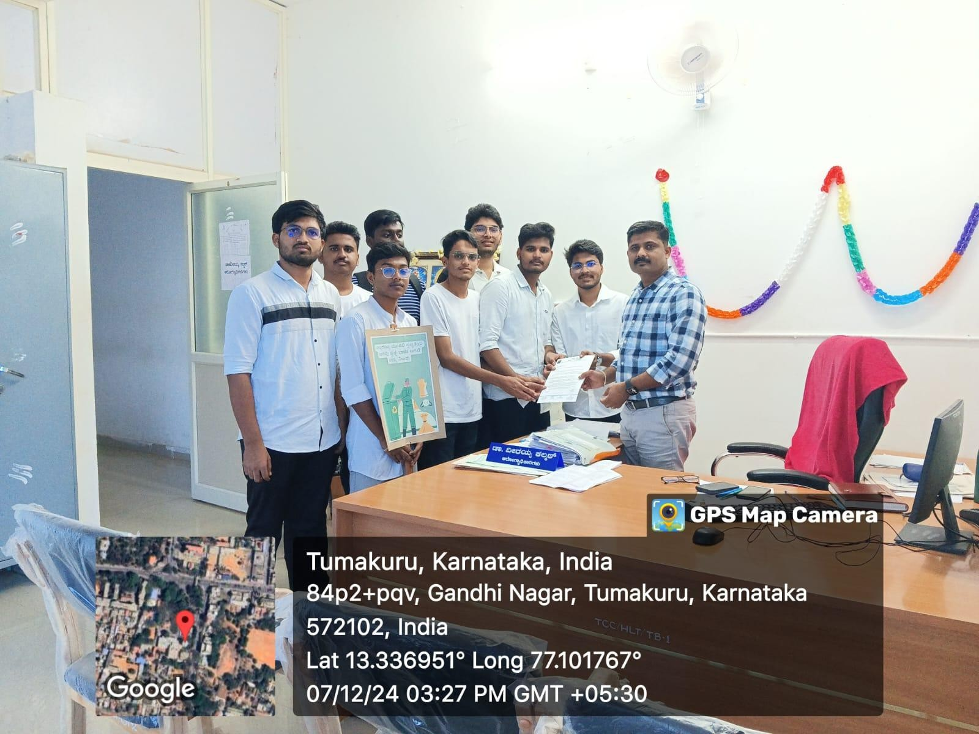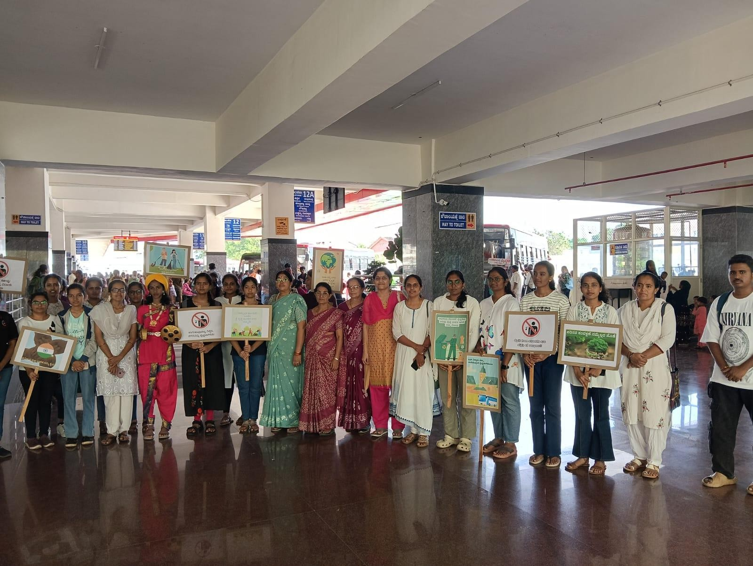

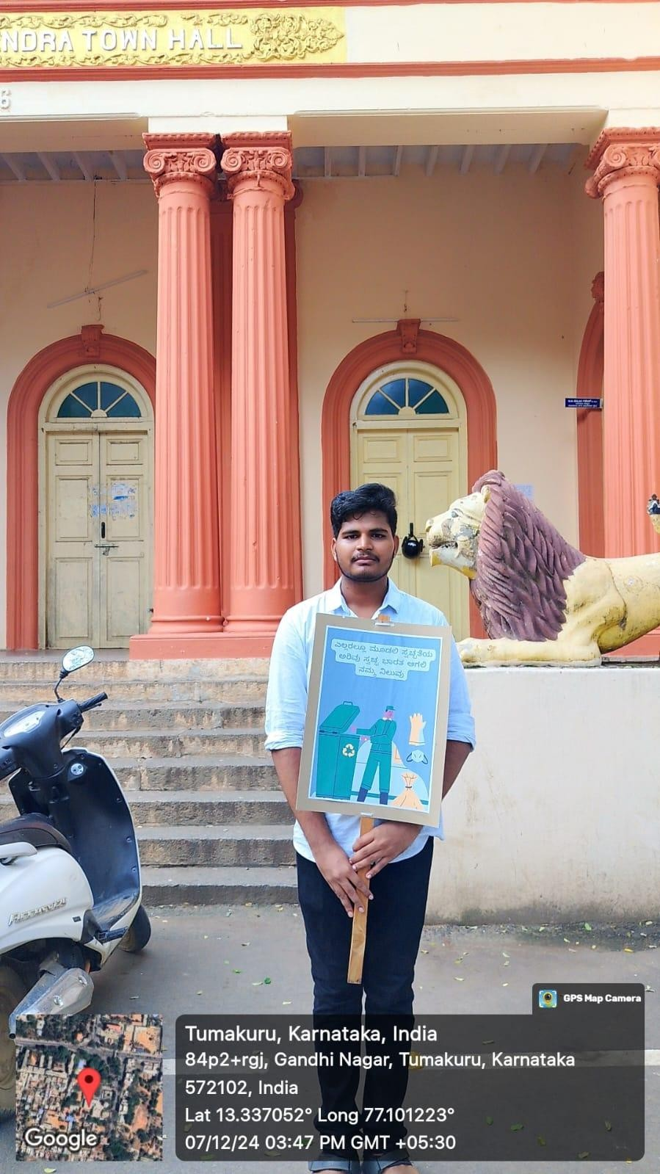

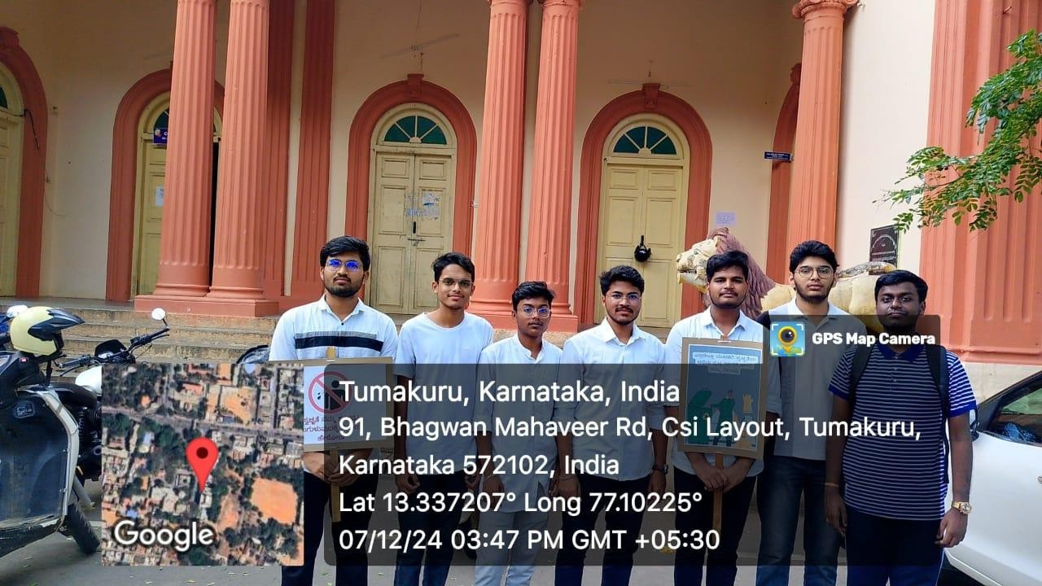

**Conclusion:**

The Manikarnika Walkathon was a meaningful initiative that emphasized the collective responsibility for maintaining a clean and healthy city. I am grateful for the opportunity provided by the Sigma CSE Club and the HoD of CSE to contribute to this impactful event. The success of the walkathon motivates continued involvement in similar social initiatives.